**READING LESSON GUIDE**

**FOR APPLE CLASS (3 – 4YRS) TERM THREE 2020**

**WEEK 1 ORIENTATION WEEK**

**WK2**

**PD 1** **Sounds (3rd tray)**

**Activities**

* Listening to the story line
* Saying to the storyline
* Doing the action for the sound
* 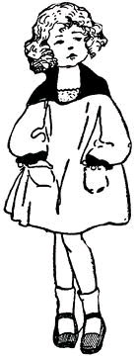Naming the pictures

fd00586_

**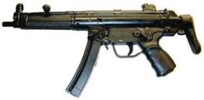**

**PD II** Sound ‘**g’**

**Activities**

* Recognizing the sound
* Saying the sound
* Doing the action for the sound
* 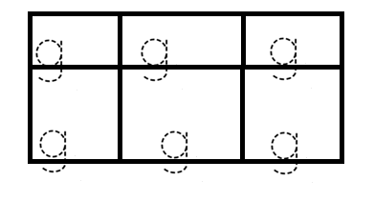Tracing

**PD III Sounds**

**Activities**

* Identifying sounds
* Sounding with the action
* Naming pictures for the sounds
* Writing

g g g

**PD IV** **Sounds**

**Activities**

* Saying the sound
* Doing the action for the sound
* Naming pictures
* 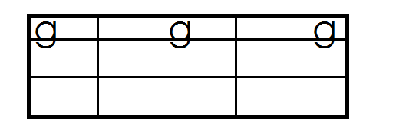Writing

**WK3**

**PD 1**

**Activities**

* Listening to the storyline of sound ‘o’
* Observing the formation of the sound
* Saying the sound with action
* Naming the pictures
* Shading

oval

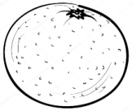

orange

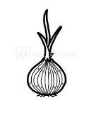

onion

**PD II** **Sounds**

**Activities**

* Singing
* Recognising the sounds
* Practising the sound
* 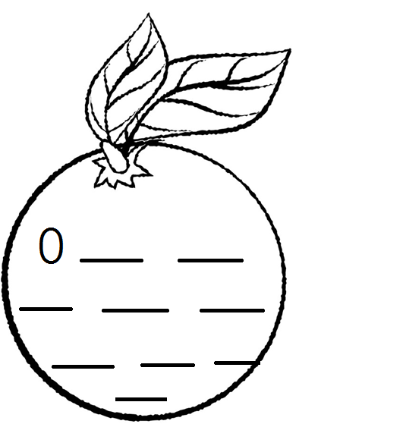Writing the sound

**PD III** **Sound** ‘**u’**

**Activities**

* Listening to the storyline
* Saying the sound
* Doing the action
* Naming the pictures
* Shading



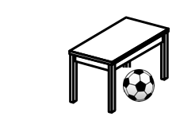

**PD IV** **Sound ‘u’**

**Activities**

* Singing
* Recognising the sound
* Saying the sound with action
* Naming the pictures
* 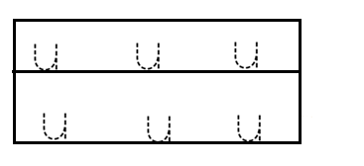Tracing

**WK 4**

**PD 1** Sound (**u**)

**Activities**

* Singing
* Recognising the sound
* Naming pictures
* Practising the sound in air
* 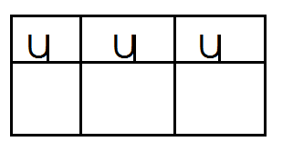Writing

**PD II** **Sounds (l)**

**Activities**

* Reading the sound with action
* Naming pictures for the sound
* Writing the sound

**PD III** **Sound (l)**

**Activities**

* Listening to the storyline of sound ‘l’
* Recognition the sound and its pictures
* Doing the action for the sound
* Shading

leaf

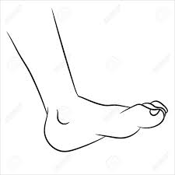

leg

**PD IV** **Sounds**

**Activities**

* Recognition the sound
* Saying the sound with action
* Naming pictures
* Practising the sound in air
* 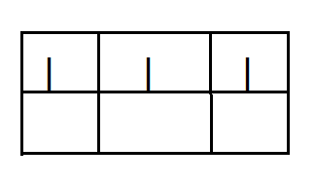Writing the sound

**WK 5**

**PD 1**  **Sounds**

**Activities**

* Recognition
* Naming
* Doing the action
* Shading

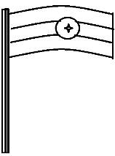

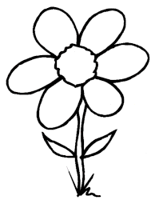

**PD II** **Sounds**

**Activities**

* Saying the sound
* Doing the action
* Naming pictures
* Tracing



**PD III** **Sounds ‘f’**

**Activities**

* Recognition
* Saying the sound with action
* Naming the pictures
* Practising the sound in space
* 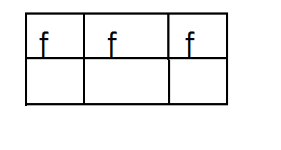Writing the sound

**PD IV** Sound **‘f’**

**Activities**

* Reading the sound with action
* Naming pictures
* Practising the sound from the chalkboard
* Writing sound “f”

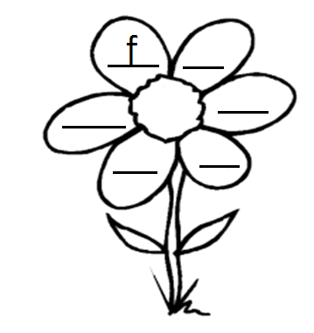

**WK 6**

**PD 1** Sound (**b**)

**Activities**

* Listening to the storyline of the sound
* Observing the formation of the sound
* Saying the sound
* Doing the action
* Naming the pictures of sound ‘b’
* Shading



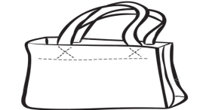

**PD II** Sound ‘**b**’

**Activities**

* Sounding with action
* Naming the pictures
* Tracing

**PD III** **Sounds**

**Activities**

* Recognizing the sound
* Sounding with the action
* Naming pictures
* Practising the sound in air
* 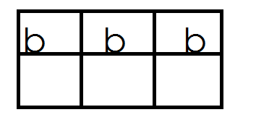Writing

**PD IV** **Sounds**

**Activities**

* Saying the sound
* Naming the pictures for the sound
* Practising the sound in air
* Writing sound “b”

b b b

**WEEK 7**

**PD 1** **Sounds**

**Activities**

* Recognising sounds and pictures
* Sounding with actions
* Practising the sounds in air
* Matching and writing

g b b

o f

u g

i o

f u

b l

**PD II** **Sounds**

**Activities**

* Recognizing sounds
* Sounding with actions
* Naming pictures
* Matching and drawing

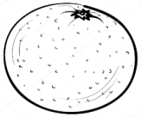















**PD III** **Sounds**

**Activities**

- Identifying sounds

- reading / saying sounds with actions

- Naming pictures

- Matching sound to picture

 u



f

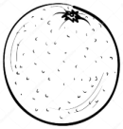

g



o



l



b

**PD IV** **Sounds**

**Activities**

- Recognising sounds

- Naming pictures

- Blending and forming words orally

a - t = at

a - n = an

a - s = as

**WEEK 8**

**PD 1** **Sounds**

**Activities**

- Sounding with actions

- Forming words

- Blending and reading

i - t = it i - s = is

i - n = in

**PDII** **Sounds**

**Activities**

- Recognition

- Sounding with actions

- forming words

o - n = on

**u** - n = un

**u** - p = up

**PD III** **Sounds**

**Activities**

- Identifying sounds

- Saying sounds with actions

- Blending and reading

- Copying

|  |  |
| --- | --- |
| at | an |
|  |  |
|  |  |

**PD IV** **Sounds**

**Activities**

- Identifying sounds and pictures

- Blending and reading

- Writing words

|  |  |
| --- | --- |
| in | is |
|  |  |
|  |  |

**WEEK 9**

**PD 1**  **SOUNDS**

**Activities**

- Identifying sounds

- Naming pictures

- Reading words

- Matching the same words

at on

in am

am at

on in

**PD II** **Sounds**

**Activities**

- Recognition

- Blending and reading orally

- Doing actions

tap man rat

cat pan hat

pot rag

**PD III** **Sounds**

**Activities**

- Saying sounds with actions

- Blending and reading words orally

pin sit net

tin egg pen leg

sun set ten

**PD IV** **Sounds**

**Activities**

- Recognising sounds

- Naming pictures

- Copy and learn

|  |  |
| --- | --- |
| tin | sun |
|  |  |

**WEEK 10**

**PD I** **Sounds**

**Activities**

- Recognition

- Naming

- Blending and reading

- Copy and draw

|  |  |
| --- | --- |
| cat | Mat |
|  |  |

**PD II** **Sounds**

Activities

- Identification

- Naming

- Blending and reading

- Matching

mat

sun

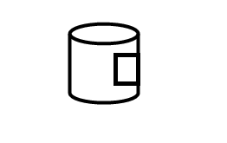

tin

**PD III** **Sounds**

**Activities**

- Recognition of sounds

- Blending and reading of words

- Filling in the missing sound

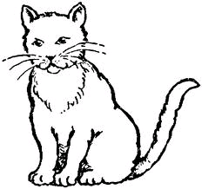

c t t n

p t s n

**PD IV** **Sounds**

**Activities**

- Recognition

- Naming

- Blending and reading sentences orally

It is a bed.

It is a cat.

It is a pin.

It is a van.

It is a pot.